EDEN ENERGY COMMISSION REPORT

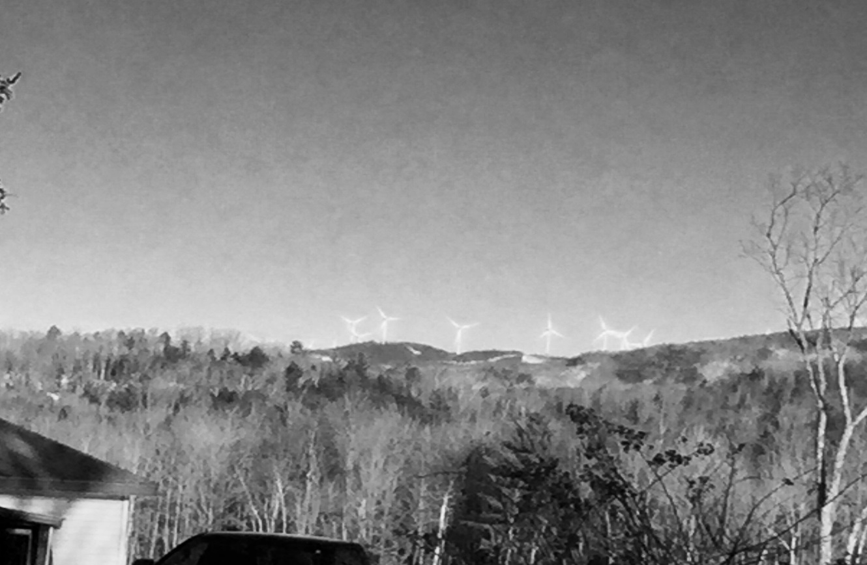

View of Wind Turbines from Eden Corners.
Photo by Craig Kneeland

This advisory committee meets the second Saturday of every month at 9 am in the ECS library. Energy conservation and alternative energy projects are being considered.
Currently, Eden taxpayers are benefitting from two private energy projects: KCW (shown above) and Eden 3E (400 panel solar). Our Governor has announced his support of having our state generate 90% alternative energy by the year 2050, so we can expect significant alternative energy projects within the next few years as people take advantage of incentives and investments to meet that goal. Individual or community net metering projects are two examples of solar electric projects that result in reduced electric bills.
The siting of alternative energy projects has a long-term impact on our town. The Eden Energy Committee is working with the Eden Planning Commission and Lamoille County Planning Commission to develop planning that will result in the PSB giving greater consideration of Eden input on the siting of large energy projects. Alternative Energy reduces the impact of climate change and can result in advantages for residents of Eden if the projects are done in accordance with established community plans.

