Warning of Annual Meeting of Eden Town School District March 7, 2017

The legal voters of the Eden Town School District are hereby notified and warned to meet at the Eden Central School on Knowles Flat Road in Eden on Tuesday, March 7, 2017 at 1:00 p.m., to act upon the following business to wit:

Article I: To elect by ballot, a Moderator;

Article II: To hear and act upon the reports of the Town School District officers;

Article III: To establish compensation for the elected officials of Eden Town School District, if any;

Article IV: Shall the voters of the Eden Town School District hold an amount of the audited fund balance as of June 30, 2016 in the amount of $174,919 to add to the
already established Capital Reserve Fund for the purpose of meeting capital needs of the Eden Central School?

Article V: To elect by ballot the following officers:

An Eden Town School District board member to serve up to December 31, 2017

Article VI:

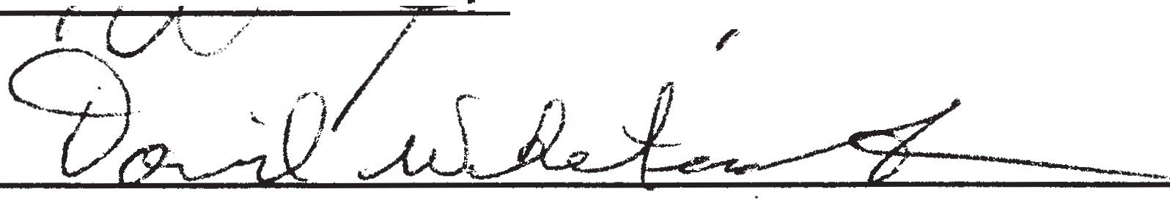

As School Directors of the Eden Town School District

Dated at Eden Town Clerk's Office for posting on this O((g day of J0 rlu.a..c at I d : 3D pM .

' 2017

Co/ VUvt
As Town Clerk for the Eden Town School District

