The Most Holy Name of Jesus Parish
ST. Gabriel’s Catholic Church

St. Gabriel’s Church was officially closed on December 11, 2016 with a final Mass by Bishop Christopher Coyne. For the past several years, St. Gabriel’s Church along with the other churches in our parish community (St. John’s in Johnson and St. Teresa in Hyde Park) did not open. All masses and church activities, including religious education are held year round at Holy Cross Church in Morrisville. The official closing and ultimate sale of the property is due to the lack of priests and parishioners. Fr. Francis Prive is our parish priest.
St. Gabriel’s started having weekly Mass at the former Deuso farm on Old Deuso Rd in 1947. In 1949, our first church was the old schoolhouse at the corner of RT118 and Warren Rd. That year, Fr. Dufault purchased property from the Leach family on RT100 for a new church site. Under the direction of Fr. Gerard Brochu, the current building was built in 1965 and dedicated by Bishop Joyce. In 2000, an addition was added providing a small hall, restroom, and kitchen and craft area.
The Ladies Guild was established in hopes to be able to provide reception meals for grieving families of our church community. During the 25 year span of Christmas Bazaars and countless other fundraisers they raised monies, helping to offset expenses that would otherwise have been incurred by the entire parish. In an effort to help defray costs the Ladies Guild accomplished its initial goal and much more. Working together to help others, friendships and faith grew.
Our parishioners were blessed with this beautiful setting in which to worship. St. Gabriel Church is but a building and the future holds change, it is a part of life. As the physical structure of St. Gabriel Church may change, its legacy will live on. St. Gabriel Church is in all who have passed through its doors, in their hearts, memories and actions – past, present and future.
We will be forever grateful to all who have supported St. Gabriel’s - our parishioners, our community and to God for giving us this precious gift.

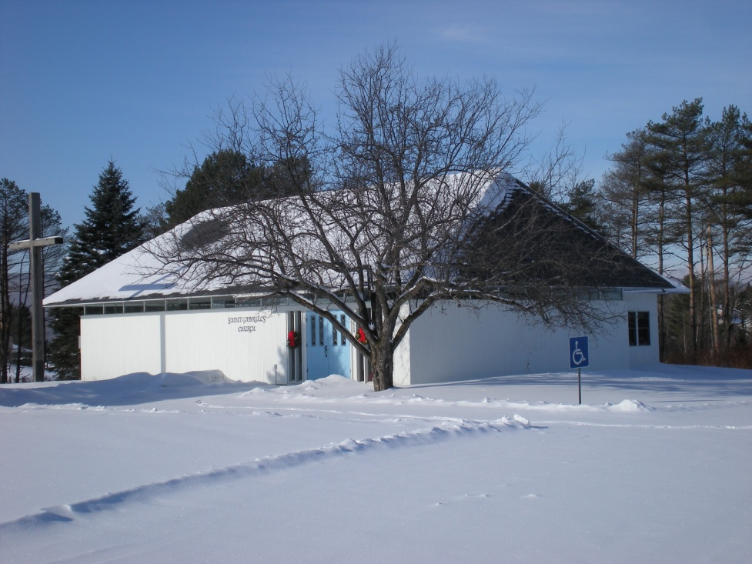

Photo by Linda Jewett

