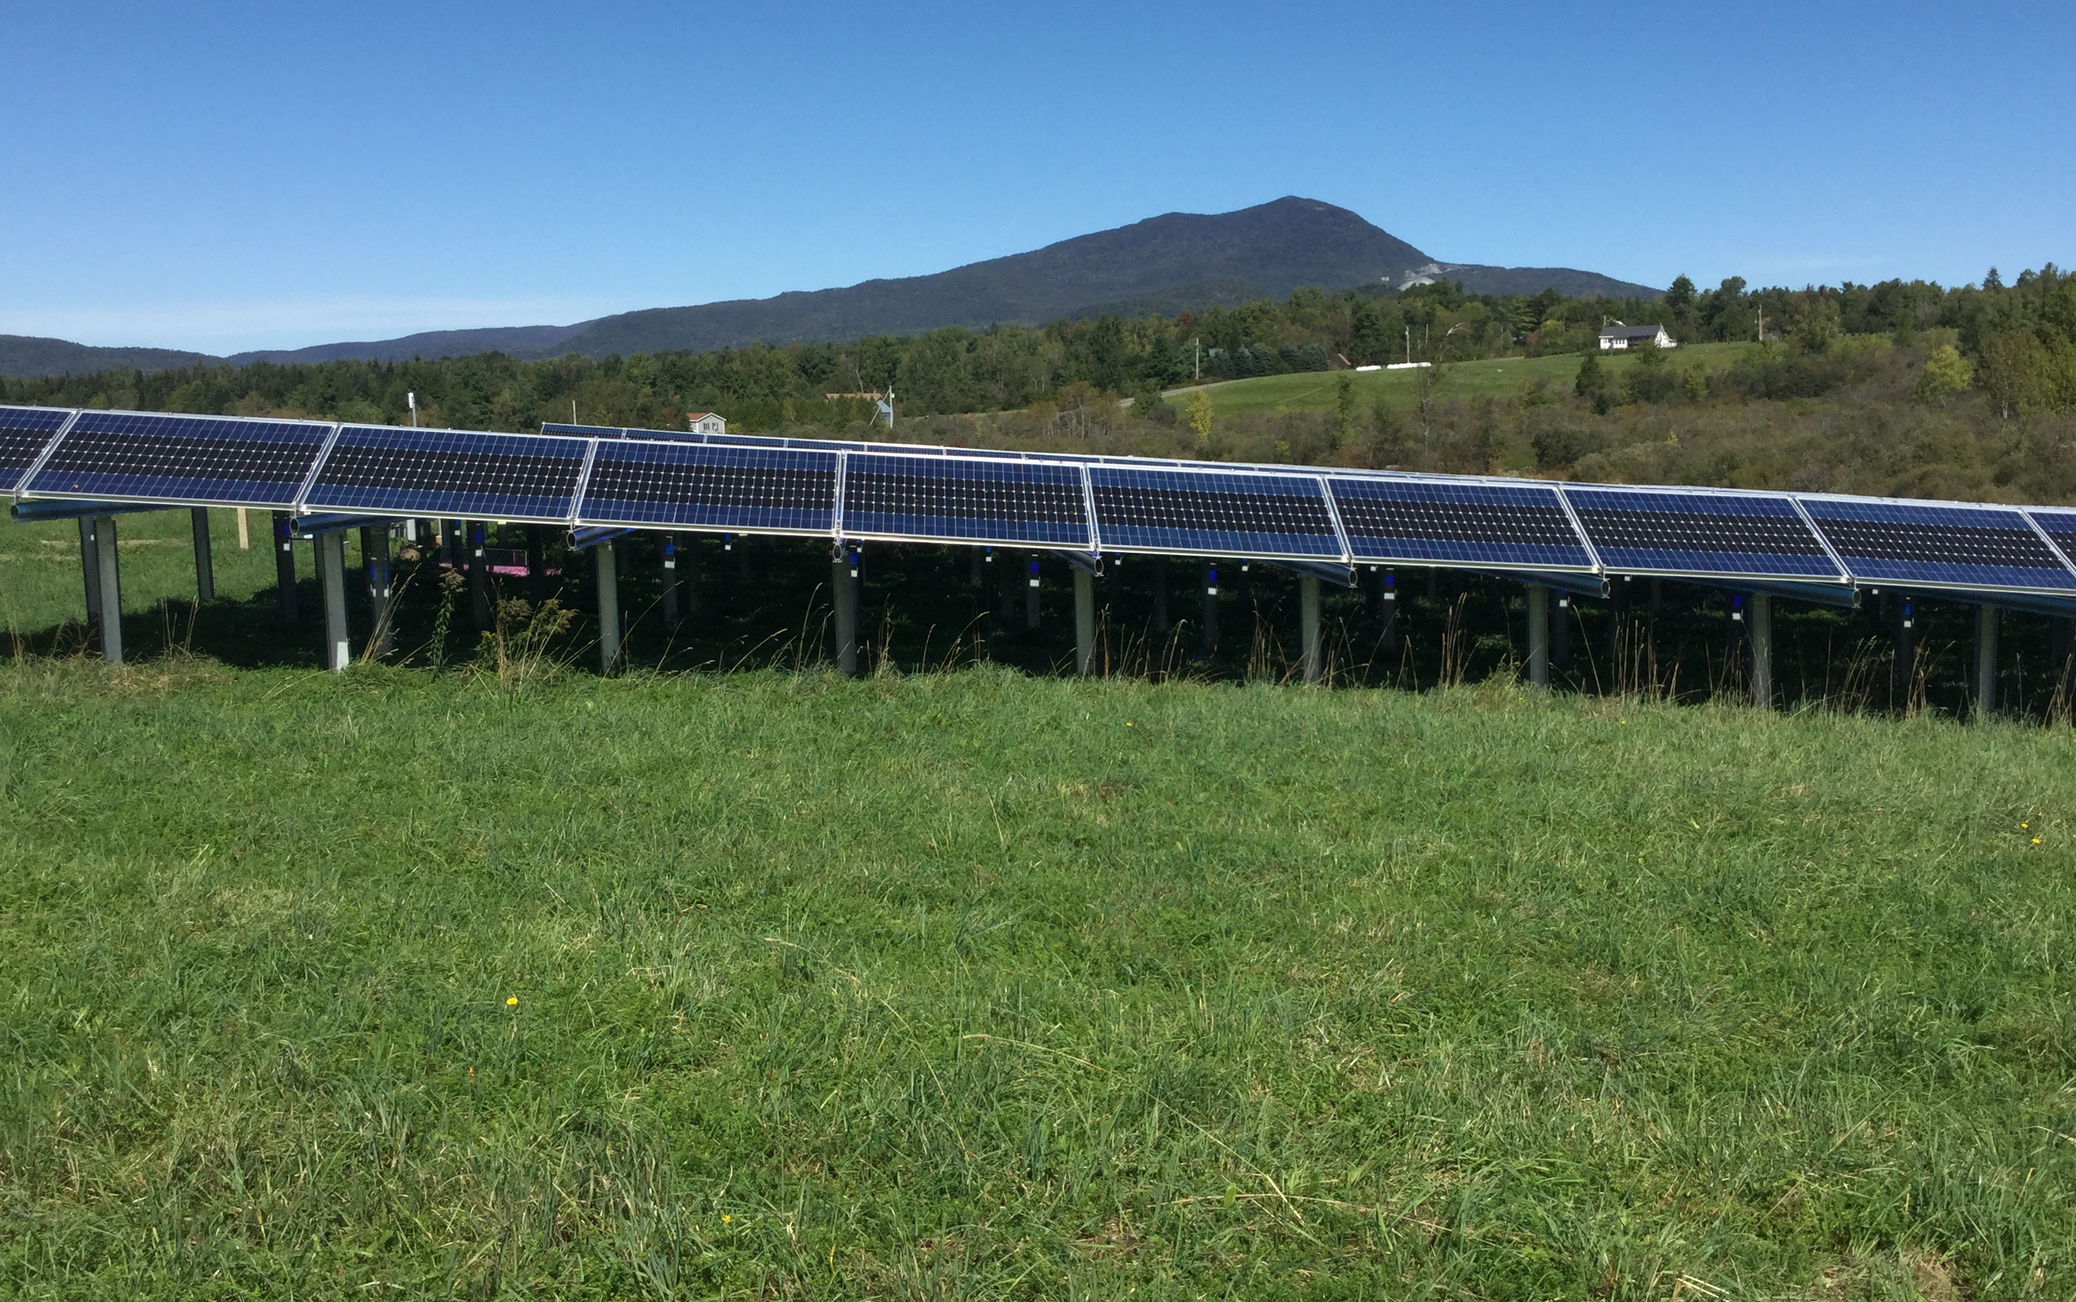
EDEN ENERGY COMMISSION REPORT

The committee promoted town purchase of some power from this privately developed solar site.
Photo by Craig Kneeland

The committee will focus on energy conservation and reduction of our carbon footprint in, and for, the benefit of the residents of Eden.

The committee will support regional efforts, in cooperation with other municipalities, for energy conservation and development.

This mission statement (above) has been adopted. The committee meets the second Saturday of each month, 9:30 AM, at ECS Library. We are seeking input from residents concerning further development of our mission statement, ideas for projects, and filling a vacancy in our five member committee. Plan to attend our next meeting if you are interested in this important topic.

