EDEN ENERGY COMMISSION REPORT

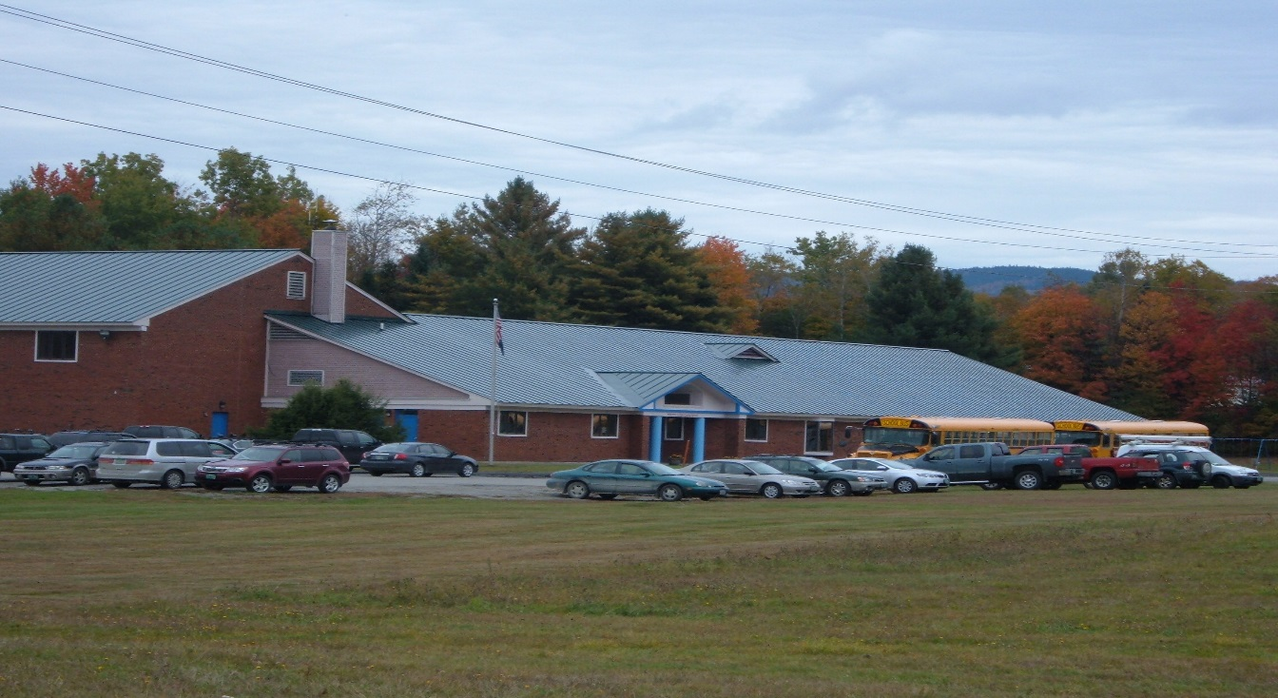

Potential Solar Site.
Photo by Town of Eden
The Eden Energy Committee (EEC) is a volunteer committee, appointed by the Selectboard. It meets the second Saturday of every month at 9 am in the ECS library. Residents with interest or expertise in energy conservation or generation are encouraged to attend and participate.
In 2017 the Eden Planning Commission updated the Town Plan and incorporated an in- depth chapter on energy. The siting of wind and solar energy projects has an impact on our town and is a consideration in our Town Plan. The EEC has been working with our Planning Commission and Lamoille County Planning Commission to develop planning that will result in the Public Service Board giving greater consideration of Eden input on the siting of large energy projects. Alternative energy reduces the impact of climate change and can result in advantages for residents of Eden if the projects are done in accordance with established community plans.
A proposal by a private renewable energy company, Suncommon, was presented to our Eden School Board and the EEC. The south and east facing aspects of the Eden Central School’s roof make it a potential site for rooftop solar generation. Suncommon proposed, at no cost to the Town or school, to install and maintain solar panels on two sections of the ECS roof. Renewable energy from these panels would reduce the ECS Electricity bill by about 10%. The proposal now rests with the Supervisory Union.
Eden residents are currently benefitting directly from two local renewable energy projects. Participation in the Eden 3E solar project saves the Town several hundred dollars a year, and over $60,000 annually is received from GMP relating to the Kingdom Community Wind Project. Other community net metering projects are resulting in reduced electric bills for individuals. Privately funded net metering projects can result in reducing electrical bills to nearly zero.

