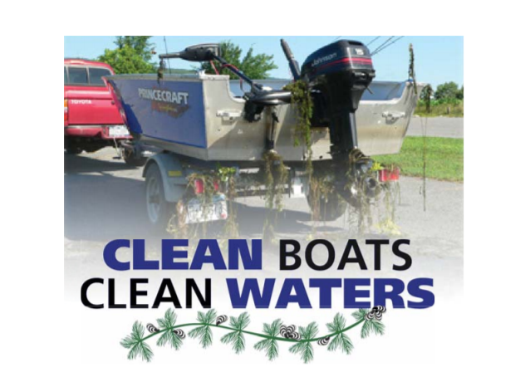**LAKE EDEN ASSOCIATION IS LOOKING FOR HELP!**

Come join our team of Greeters, working at the VT Fishing Access on Rte. 100 here in Eden for the 2023 season! Greeters gather data about what type of boats they see enter and exit Lake Eden, inspect boats for invasive species and help educate boaters about how to keep invasive water species from riding along on their boats to other waterbodies!

Flexible hours available—pay $14/hr.

For More Info: Call 802-635-9716, Ask for Art